1. **Introduction to Database and Database Management**

**What is a Database?**

A **database** is an organized collection of data that is stored and managed to meet user needs. It enables efficient storage, retrieval, and manipulation of data.

Examples of data include:

* Names, addresses, and contact numbers in a phone book
* Sales records in a retail store
* Inventory details in a warehouse

**Database Management System (DBMS)**

A **Database Management System (DBMS)** is software that allows users to create, manage, and interact with databases. It acts as an interface between the database and the end users or applications, ensuring data is consistently organized and remains easily accessible.

**Key Features of a DBMS**

1. **Data Storage**: Efficiently stores large amounts of data.
2. **Data Retrieval**: Enables fast retrieval of data using queries.
3. **Data Integrity**: Ensures accuracy and consistency of data.
4. **Data Security**: Protects data from unauthorized access.
5. **Concurrency Control**: Allows multiple users to access data simultaneously.
6. **Backup and Recovery**: Provides mechanisms to recover data in case of failure.

**Types of Databases**

1. **Relational Database (RDBMS)**: Stores data in tables with rows and columns. Examples: MySQL, PostgreSQL, Oracle DB.
2. **NoSQL Database**: Handles unstructured or semi-structured data. Examples: MongoDB, Cassandra.
3. **Distributed Database**: Data is spread across multiple locations. Example: Apache Cassandra.
4. **Cloud Database**: Stored on a cloud platform. Examples: Amazon RDS, Google BigQuery.

**Advantages of Using a Database**

1. **Efficient Data Management**: Centralized control of data ensures easy access and manipulation.
2. **Data Security**: Implements access controls and encryption.
3. **Data Integrity**: Maintains consistency across operations.
4. **Scalability**: Handles large volumes of data with ease.
5. **Reduced Redundancy**: Prevents duplication of data by normalization.

**Common DBMS Software**

* **MySQL**: Open-source RDBMS widely used for web applications.
* **Oracle Database**: Known for its advanced features and scalability.
* **Microsoft SQL Server**: Popular for enterprise-level applications.
* **MongoDB**: A leading NoSQL database.
* **SQLite**: Lightweight DBMS for local storage needs.

**Core Components of a DBMS**

1. **Database Engine**: Handles data storage, processing, and retrieval.
2. **Database Schema**: Blueprint of how data is organized.
3. **Query Processor**: Translates user queries into database instructions.
4. **Transaction Manager**: Ensures data integrity in multi-user environments.

**Basic Database Operations**

1. **CRUD Operations**:
   * **C**reate: Add new data.
   * **R**ead: Retrieve data.
   * **U**pdate: Modify existing data.
   * **D**elete: Remove data.
2. **Querying**: Use Structured Query Language (SQL) to interact with the database.

**Conclusion**

Databases and DBMS play a vital role in managing data for businesses, applications, and users. Understanding their concepts is essential for efficient data handling and problem-solving in the digital age.

1. **Types of Databases in Database Management**

Databases come in various types, each designed to handle specific data storage and processing requirements. Below is a classification of common database types:

### **1. Relational Database (RDBMS)**

* **Description**: Stores data in a structured format using rows and columns (tables).
* **Key Features**:
  + Data is organized in relationships (tables).
  + Uses **Structured Query Language (SQL)** for data manipulation.
  + Ensures data integrity with constraints like primary keys and foreign keys.
* **Examples**: MySQL, PostgreSQL, Oracle Database, Microsoft SQL Server.

### **2. NoSQL Database**

* **Description**: Designed for handling unstructured or semi-structured data, offering flexibility in data modeling.
* **Key Features**:
  + Does not use fixed schemas or tables.
  + Ideal for large-scale data and real-time applications.
  + Types of NoSQL Databases:
    - **Document-based**: Stores data as JSON or BSON (e.g., MongoDB).
    - **Key-Value Stores**: Data stored as key-value pairs (e.g., Redis).
    - **Column-based**: Uses columns instead of rows (e.g., Apache Cassandra).
    - **Graph-based**: Represents data as nodes and edges (e.g., Neo4j).
* **Examples**: MongoDB, Couchbase, DynamoDB, Cassandra.

### **3. Distributed Database**

* **Description**: A single logical database distributed across multiple locations or systems.
* **Key Features**:
  + Ensures high availability and fault tolerance.
  + Data can be replicated or partitioned across servers.
  + Suitable for large-scale applications.
* **Examples**: Google Spanner, Apache Cassandra, Amazon DynamoDB.

### **4. Cloud Database**

* **Description**: A database that runs on cloud computing platforms, accessible via the internet.
* **Key Features**:
  + Scalability and flexibility to handle varying workloads.
  + Pay-as-you-go pricing model.
  + Managed services handle backups, scaling, and updates.
* **Examples**: Amazon RDS, Google BigQuery, Microsoft Azure SQL Database.

### **5. Data Warehouse**

* **Description**: A centralized repository designed for analytical queries and reporting.
* **Key Features**:
  + Optimized for **read-heavy** workloads.
  + Aggregates data from multiple sources for Business Intelligence (BI).
  + Uses Online Analytical Processing (OLAP).
* **Examples**: Snowflake, Amazon Redshift, Google BigQuery.

### **6. Operational Database (OLTP)**

* **Description**: Designed for day-to-day operations like transaction processing.
* **Key Features**:
  + Supports high-speed query processing.
  + Handles CRUD operations (Create, Read, Update, Delete).
  + Ensures data consistency using ACID properties.
* **Examples**: MySQL, Oracle Database.

### **7. Object-Oriented Database**

* **Description**: Stores data in the form of objects, as used in object-oriented programming.
* **Key Features**:
  + Supports complex data types like multimedia, images, and videos.
  + Data is represented as objects with attributes and methods.
* **Examples**: ObjectDB, db4o.

### **8. Time-Series Database**

* **Description**: Designed for storing and querying time-stamped data.
* **Key Features**:
  + Ideal for applications like monitoring, IoT, and analytics.
  + Efficiently handles large volumes of sequential data.
* **Examples**: InfluxDB, TimescaleDB.

### **9. Hierarchical Database**

* **Description**: Data is organized in a tree-like structure with parent-child relationships.
* **Key Features**:
  + Each child node has one parent.
  + Suitable for applications requiring a predefined hierarchy.
* **Examples**: IBM Information Management System (IMS).

### **10. Network Database**

* **Description**: Uses a graph structure to represent relationships, allowing multiple parent-child relationships.
* **Key Features**:
  + Flexible representation of complex relationships.
  + Data is accessed via pointers or links.
* **Examples**: Integrated Data Store (IDS), CODASYL DBMS.

### **11. Graph Database**

* **Description**: Stores data as nodes, edges, and properties to represent relationships.
* **Key Features**:
  + Excels in managing highly interconnected data.
  + Commonly used in social networks, fraud detection, and recommendation systems.
* **Examples**: Neo4j, Amazon Neptune.

### **12. Embedded Database**

* **Description**: A lightweight database embedded within an application.
* **Key Features**:
  + Runs as part of the application, with minimal resources.
  + Common in mobile and IoT devices.
* **Examples**: SQLite, Berkeley DB.

### **13. Columnar Database**

* **Description**: Organizes data in columns rather than rows, optimized for analytical workloads.
* **Key Features**:
  + Enables fast aggregation and query performance.
  + Commonly used in data warehouses and BI systems.
* **Examples**: Apache HBase, Google Bigtable, Amazon Redshift.

### **14. Spatial Database**

* **Description**: Designed to store and query spatial data like maps and geolocation.
* **Key Features**:
  + Supports geographic data types like points, lines, and polygons.
  + Used in GIS (Geographic Information Systems) applications.
* **Examples**: PostGIS, Oracle Spatial.

**By understanding these database types, organizations can choose the most suitable one based on their specific needs, such as real-time performance, analytical capabilities, or scalability.**

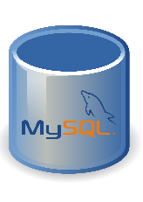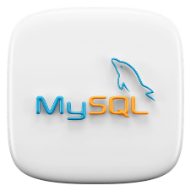**My SQL**   

**What is My SQL?**

* Most popular RDBMS - based on SQL
* Swedish company MySQL AB ---> Sun Microsystems --> Oracle
* Now, supported and managed by Oracle Corporation.
* Used by: Facebook, YouTube, Flickr, etc.
* Written in C and C++
* Initial Release: 23 May 1995

**MySQL Workbench?**

* User Interface for MySQL i.e. a graphical tool for working with MySQL servers and databases.
* Supports MySQL server versions 5.6 and higher

**MySQL Features**

* Based on SQL
* Open Source
* Friendly & compatible with PHP. Connect easily & manipulate databases.
* Based on client-Server architecture
* Secure and highly Flexible
* Scalable: Supports large databases
* 50 million rows or more in a table.
* Default file size limit for a table is 4GB(can be increased)
* Compatible with major Operating Systems and languages.

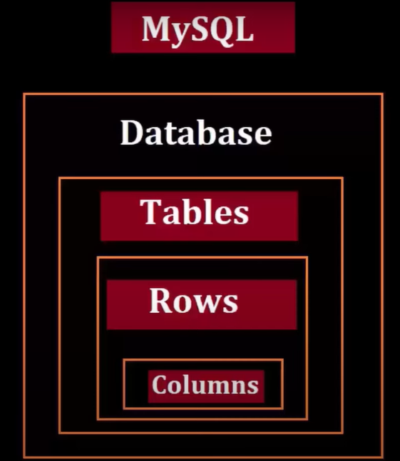

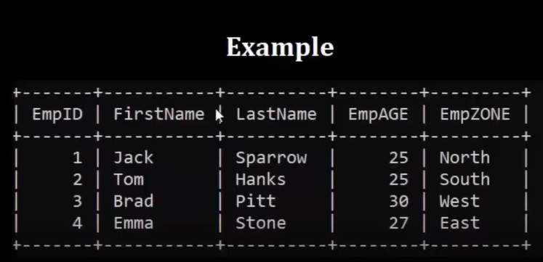

**Difference Between** **SQL vs NoSQL**

|  |  |  |
| --- | --- | --- |
|  | **SQL** | **NoSQL** |
| Model | Tables with fixed rows and columns | Document: JSON, BSON, XML objects documents, Key-value: key-value pairs. Wide-column: tables with rows and dynamic columns, Graph: nodes |
| History | SQL came in the 1970s | NoSQL came in late 2000s |
| Examples | Oracle, MySQL, Microsoft SQL Server, and PostgreSQL | Document: MongoDB and CouchDB, Key-value: Redis and DynamoDB. Wide-column: Cassandra and HBase, Graph: Neo4j and Amazon Neptune |
| Schemas | Rigid | Flexible |

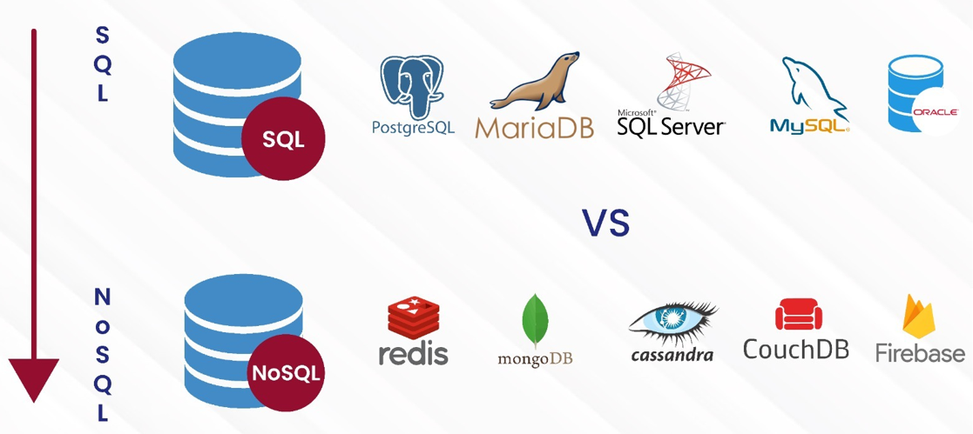

[**https://www.mysql.com/**](https://www.mysql.com/)

**Install MySQL Server**

**+**

**Install MySQL Workbench**

**+**

**Install MySQL Shell**

What Port Does MySQL Use?

MySQL uses port **3306** by default.

MySQL Version 8.0.40

MySQL --version

MySQL -u root -p

show databases;

create database mydb;

show databases;